Practical No.2
Aim: Installation and configuration of virtualization using KVM.(Kernel based virual machine)
Date 13/12/19

Step 1: Type in the following command to check compatibility.
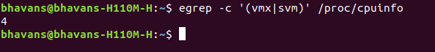
Step 2: Run the following command to install KVM.
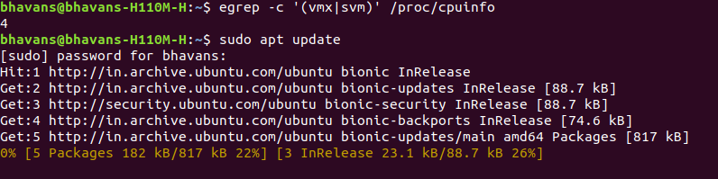
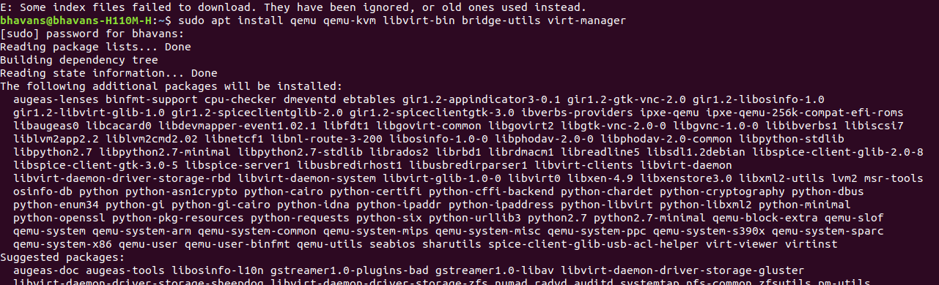
Step 3: type the following command.The virtual machine manager windows starts.
sudo virt-manager
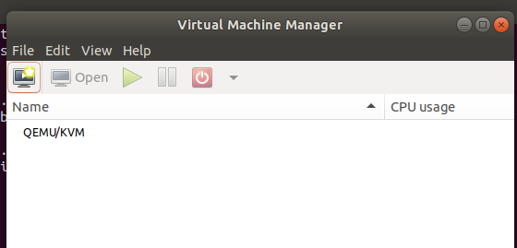

Step 4: create a new virtual machine and click on forward.
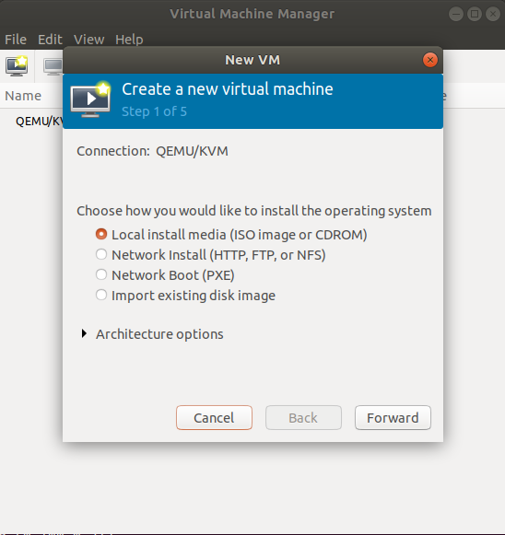
Click on browse and add the kali linux setup file from documents.
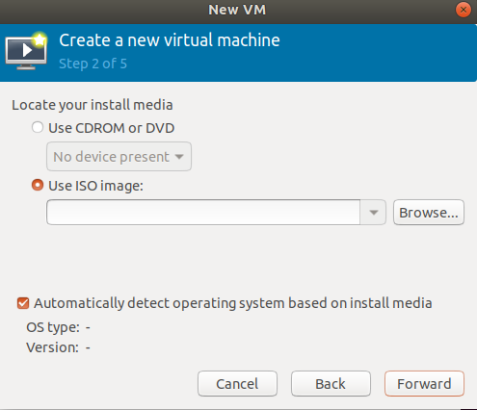

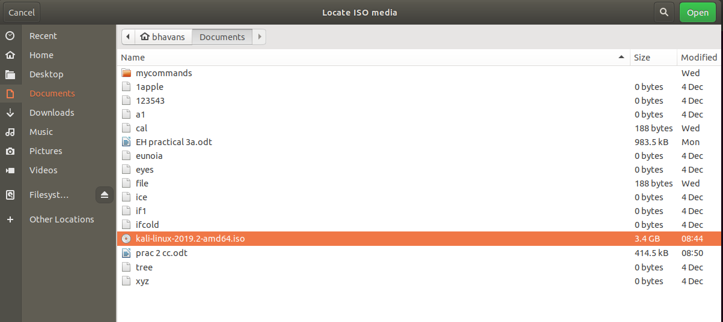
click on forward :
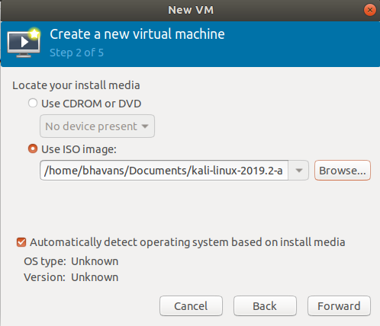

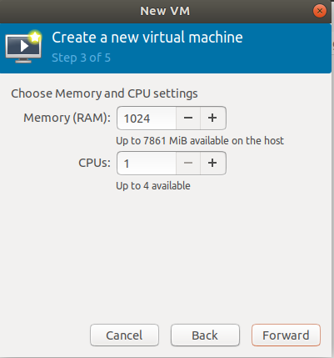
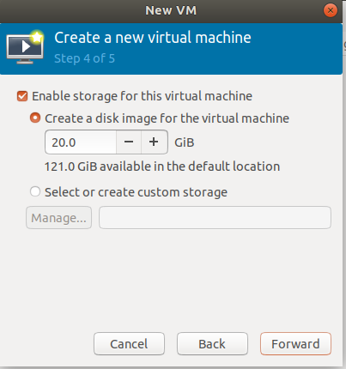

click on forward and then finish
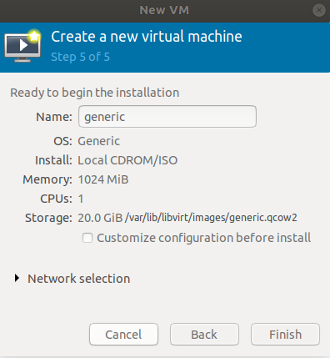

output:

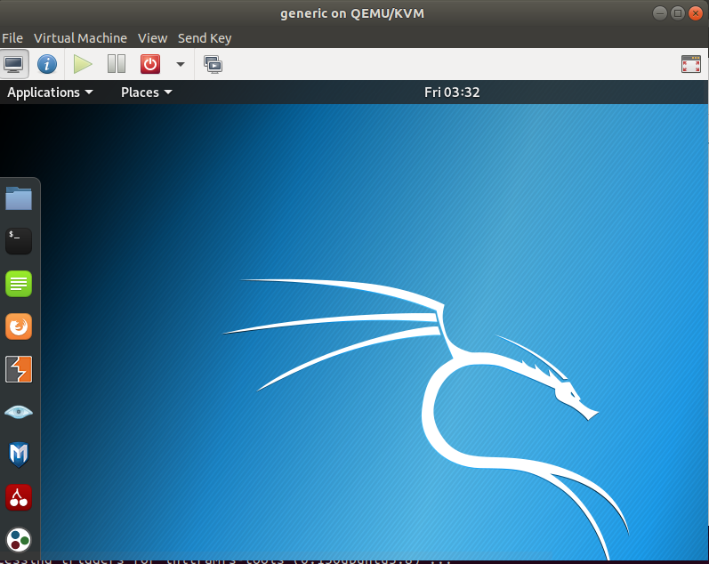
kali linux is installed

